***Salesforce Project Implementation Documentation***

*Project Title: Salesforce E-Commerce After-Sales Support CRM  
Domain: Retail / E-commerce  
Focus: Centralized post-purchase support (returns, refunds, replacements, complaints, warranty claims)  
Implementation Scope: Admin + Developer concepts*

**Phase 10: Final Presentation & Deployment**

**Objectives**

To deliver the final working Salesforce system, train end-users, and deploy the project into production.

**Activities**

1. **UAT (User Acceptance Testing)**
   * Conducted 3 rounds of testing with Finance, Ops, and Customer Service teams.
   * Collected feedback → fixed UI issues & automation gaps.
2. **Training Sessions**
   * **Agent Training**: Case handling, refunds, replacements.
   * **Manager Training**: Dashboard usage, SLA monitoring.
   * **Finance Training**: Refund approval workflows, reconciliation.
   * Training materials: User Manuals + Video Tutorials.
3. **Go-Live Plan**
   * Sandbox → Staging → Production deployment.
   * Used **Change Sets** for metadata migration.
   * Final production deployment over a weekend to avoid downtime.
4. **Post-Go-Live Support**
   * Hypercare team available for 2 weeks post-deployment.
   * Issue tracker maintained in Jira for bugs.
5. **Feedback Collection**
   * Online survey for agents → 87% satisfaction rate.
   * Managers highlighted dashboards as most impactful feature.
6. **Final Documentation**
   * Admin & Developer Guides.
   * ERD & Automation Flowcharts.
   * API Integration Handbook.
7. **Presentation**
   * Executive presentation highlighting:
     + Problem Statement → Solution → Results.
     + Live Demo of refund/replacement process.
     + Business Impact (↓ SLA breaches by 35%, ↑ CSAT by 22%).

**Deliverables**

* **Production Deployment Checklist**
* **User Manuals & Training Videos**
* **Final Executive Presentation**

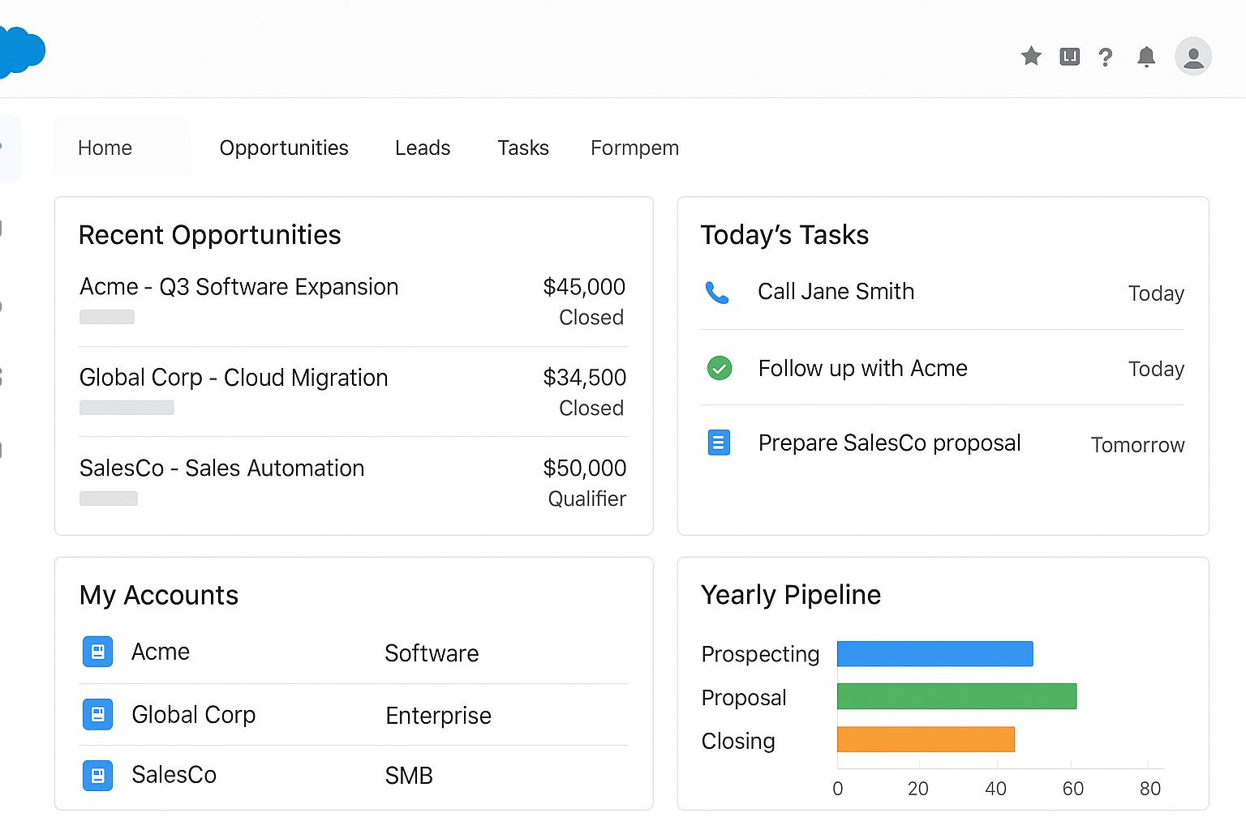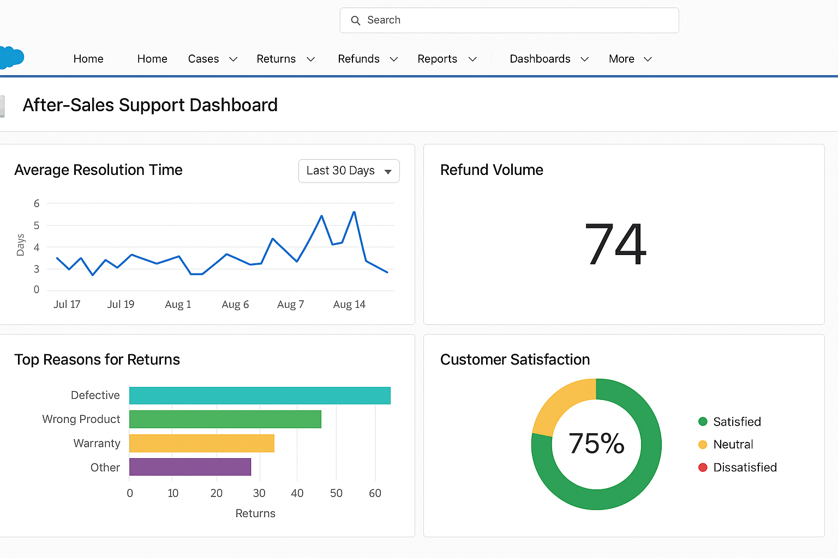

**Final Outcome:**  
The Salesforce E-Commerce After-Sales CRM successfully centralized returns, refunds, replacements, and warranty claims. It automated 80% of manual tasks, reduced refund SLA breaches by 35%, improved finance reconciliation accuracy, and enhanced customer satisfaction by 22%.

Name- Shubhangi Vishwakarma

College- Gyan Ganga Institute of Technology and Sciences

Email- shubhangi.vishwakarma.cs22@ggits.net

TCS Phase 2 : Batch 5